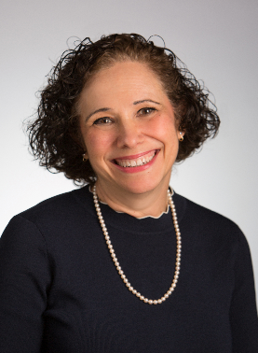
Sandra D. Glazier is an equity shareholder at Lipson Neilson P.C., Bloomfield Hills, Michigan. She concentrates her practice in probate litigation, estate planning and administration, and family law. Sandra not only actively practices in these areas, but she has also been engaged to act as a testifying or consulting expert. She has also served as a mediator in probate and family court cases. Sandra is active with the Oakland County Bar Association (OCBA), having held numerous leadership positions and continues as an appointment member of its Legislative Committee. Sandra is also active in the ABA Real Property, Trust and Estate Law (RPTE) section. She currently serves on RPTE’s Estate Diversity and Inclusion Committee and as Vice-Chair of RPTE’s Elder Law and Long Term Care Committee,
Sandra is a Commissioner on the ABA’s Commission on Law and Aging and previously served as a Special Advisor to that Commission. She was elected to serve on the Michigan Probate Section’s Council for a three-year term that began September 2021 and currently serves as chair of that Section’s Guardianship, Conservatorship and End of Life Committee as well as being an active member on other committees.
Sandra is a nationally recognized author in legal publications and presents nationally on issues such as undue influence, ethical duties when representing vulnerable adults, defending fiduciaries, protective estate planning practices, and the attorney-client privilege. Sandra is on the Trust & Estates Magazine Editorial Advisory Board for Planning and Taxation, and is an Advisor to the Notre Dame Tax and Estate Planning Institute. Sandra was awarded the OCBA’s Distinguished Service Award; received Top Lawyer, Super Lawyer, Leading Lawyer, Martindale-Hubbell AV Preeminent, and Accredited Estate Planner (AEP) designations; and was awarded Trusts & Estates Magazine Distinguished Author in Thought Leadership as well as Bloomberg Tax Estates, Gifts and Trusts Tax Contributor of the Year for 2018. For more background about Sandra, see https://lipsonneilson.com/attorney/sandra-d-glazier.

Contact information: Sandra D. Glazier, Esq., Lipson Neilson, P.C., 3910 Telegraph Road, Suite 200, Bloomfield Hills, MI 48302. Telephone: (248) 593-5000 ext. 138. Email: sglazier@lipsonneilson.com
Martin M. Shenkman, CPA, MBA, PFS, AEP (distinguished), JD, is an attorney in private practice in New York. His practice concentrates on estate and tax planning, planning for closely held businesses, estate administration. He has published 42 books and more than 1,300 articles. Mr. Shenkman serves and has served on the editorial board of many tax, estate and real estate publications and is currently on the advisory board of the Notre Dame Tax and Estate Planning Institute. For more background about Martin, see https://shenkmanlaw.com/the-firm/

Contact information: shenkman@shenkmanlaw.com

The presenters wish to also thank Howard Zaritsky, Jonathan Blattmachr and Joseph Garin who also contributed generously to some of the articles that are contained in these materials in support of our presentation on Defensive Practices When Recommending an Estate Planning Proposal.

